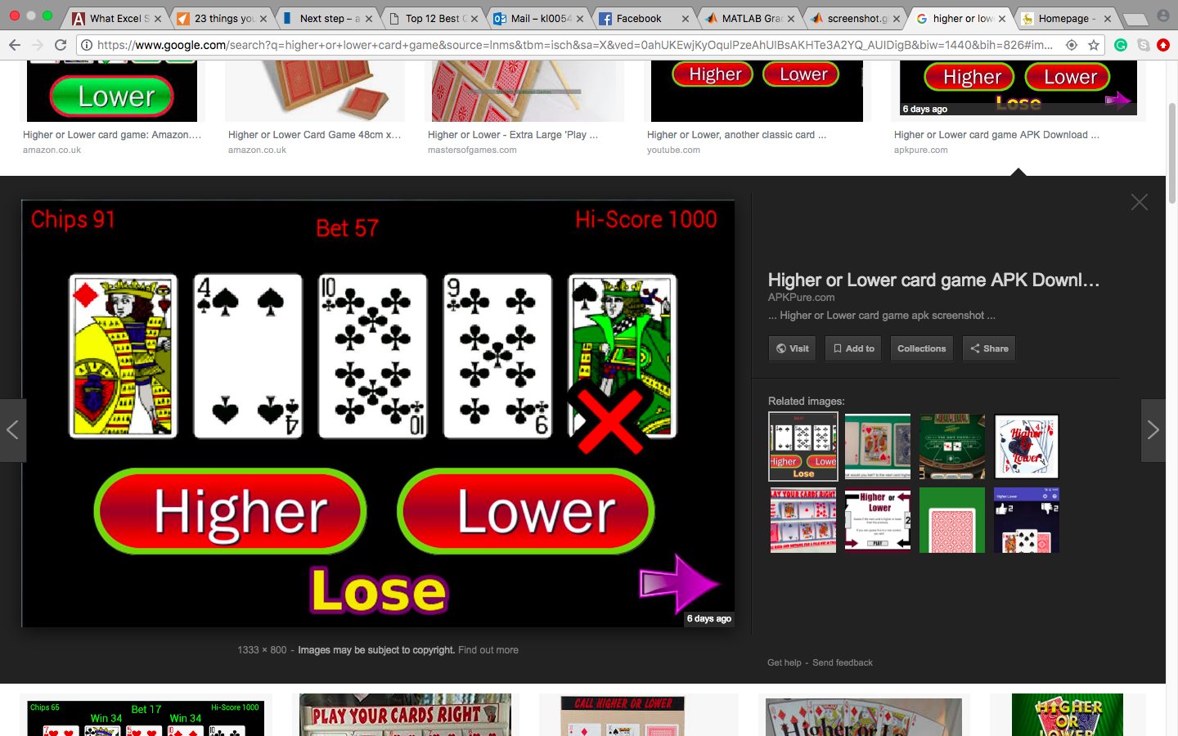

-this is too basic if it’s just a one-time-game

-five card would face down first , START button

- after clicking start, first card reveal, and two options appear, HIGHER or LOWER

-one would be selected, and the second card would reveal,

After 5 cards have revealed, two options would be appeared, ( CONTINUE, CASH OUT)

If the player chose ‘CONTINUE’, a new game starts, but the score is carried on to the next round

5 round max?

(have to learn how to code the order of the card)

Versions  
1) basic – same 5 cards everytime

2)medium- random cards (13) queen jack king have different values to avoid same card value

3)hard- include suits

Score:

Get one right>>> +100

Get two right >>> +200

Get three right >>> +300

Get four right >>> +400 (in a roll)

Get it wrong >> lose everything